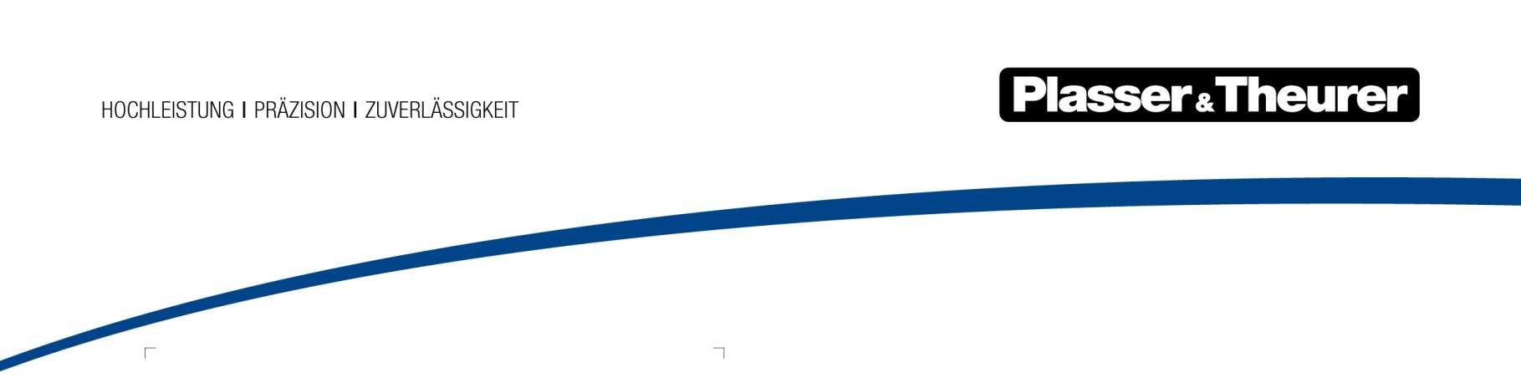

August 2024

Mobile testing lab for urban rails
Local transport operating companies have special requirements in terms of inspecting and measuring infrastructure. They need more flexibility to perform measuring services quickly and easily on site. The Plasser InfraSpector Truck moves autonomously on roads and rails. It can be put on track and taken off again particularly fast in tight spaces.
On track, it is also accredited as a testing lab in accordance with DIN ISO/IEC 17025, a decisive factor for the quality and reliability of the measurements. This international standard specifies detailed requirements for the competence, impartiality, and consistent working method of testing labs to ensure reliable measuring results. The parameters provided are the basis for determining causal relationships related to railway tracks.
The mobile testing lab measures the track geometry, the longitudinal and transverse rail profile as well as the structure gauge and the ballast bed profile. Additional parameters can be integrated on request. The new Plasser InfraSpector Truck is a world’s first and will be shown at the InnoTrans outdoor display south (T2/55).
A new offer for customized infrastructure diagnostics
With the new Plasser InfraSpector series, Plasser & Theurer offers individually configurable solutions for measuring and inspecting railway infrastructure. Four different diagnostic areas focus on relevant parameters for tracks (B), rails (R), turnouts (S), and overhead contact lines (C).
If required, they can be analysed as precise status information and translated into recommended actions. Thanks to a comprehensive partner network with dedicated experts, Plasser & Theurer can offer these complete packages from a single source. The portfolio includes vehicles and systems - including maintenance if required - or data and analyses that customers can purchase as a service.
As measuring and inspection is also a major topic outside of local transport, the range includes the Plasser InfraSpector Truck as well as self-propelled track inspection vehicles and integration into modular mounted structures on container carrying wagons.

Take time for your visit to InnoTrans and meet us in Hall 26 (Stand 270) and on the outdoor display south (T2/50 + 55, T3/50).

Image | File name | Caption
 | Plasser InfraSpector Truck.jpg | The Plasser InfraSpector Truck offers measuring services for urban tracks.
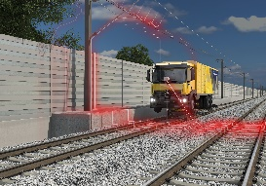 | Structure-gauge measuring.jpg | The Plasser InfraSpector series works on tracks, rails, turnouts, and overhead contact lines.

Plasser & Theurer in brief
- Founded in 1953
- Around 2,200 staff members in Austria
- Around 6,000 staff members at 22 partner companies throughout the world and in Austria
- Range of products: machines and systems for laying and installing, renewing, and maintaining tracks and overhead contact lines
- More than 17,800 heavy-duty machines supplied to 110 countries
- Export rate of 93%
- Main factory in Linz, head office in Vienna
- Service, repair, and spare parts depots all over the world
- Largest sales markets overall: Germany, USA, UK, India, Japan, France, Austria, Brazil, Spain, Australia
- Customers: railway operators, construction companies, urban transport authorities, industrial and mine railways
- More than 2,500 active patents
- 14 international certificates/qualifications (such as ISO 9001:2015, ISO 14001:2015, ISO 37001:2016, ISO 37301:2021, ISO 45001:2018, ISO 50001:2018)

Contact:
Plasser & Theurer, Export von Bahnbaumaschinen Gesellschaft m. b. H.
1010 Vienna, Johannesgasse 3
Tel.: +43 1 51572-0
Fax: +43 1 5131801
Email: presse@plassertheurer.com
https://www.plassertheurer.com/en/company/press
“Plasser & Theurer” and “Plasser” are internationally registered trademarks.

