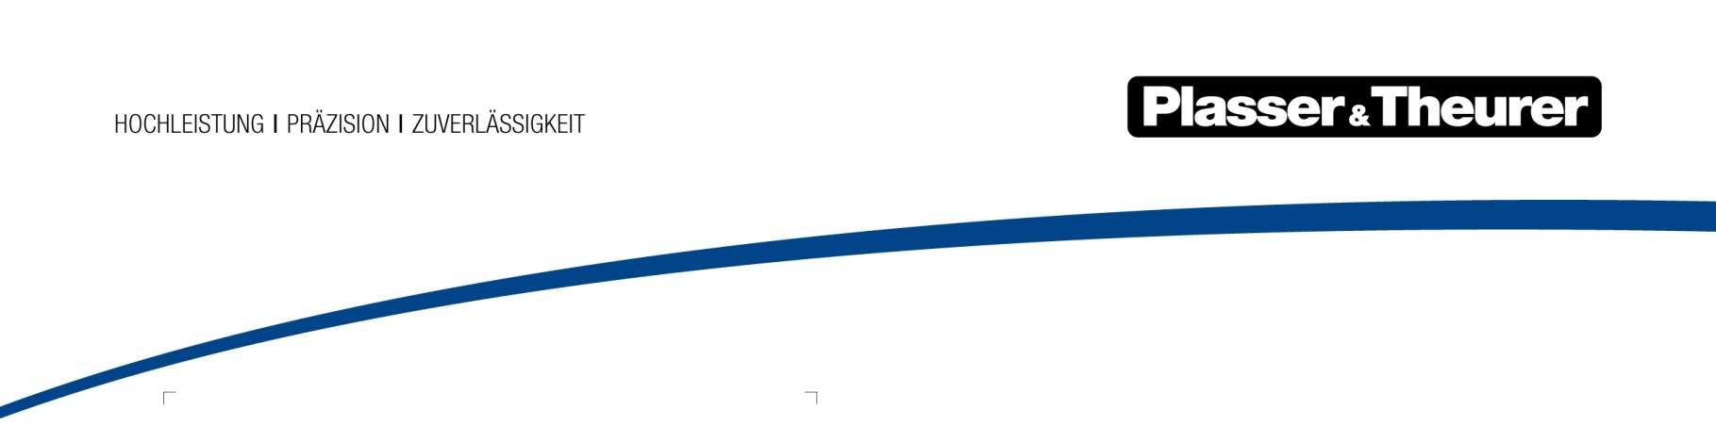

June 2024

Retrofit for the Unimat 09-32/4S Dynamic in less than four months
It is important for our customers to have retrofits of existing machines completed in a short space of time. In this respect, the retrofit of the Unimat 09-32/4S Dynamic by STRABAG AG was a great success. After less than four months, the machine left Plasser & Theurer’s Life Cycle Service Competence Centre in Linz. It was back in operation immediately afterwards.
STRABAG AG’s universal tamping machine has been in use for 13 years. After these intensive years of use, it was refurbished and retrofitted at the same time. Peter Schuckert, Head of Railway Construction Machinery, STRABAG AG: “We decided in favour of the retrofit at Plasser & Theurer mainly for two reasons. First, the expertise of the manufacturer, who knows the machines inside out, was important to us. They know which updates are possible and make sense. Plus, they know how to implement them. Second, it was also crucial to install original spare parts. They fit together perfectly and then everything works exactly as usual.”
Retrofit in the new Life Cycle Service Centre in Linz
Plasser & Theurer’s new Competence Centre was set up to create ideal working conditions for large projects such as retrofits. The available space is also suitable for larger machines, and the technical equipment is state-of-the-art. In December 2023, STRABAG AG’s Unimat 09-32/4S Dynamic arrived in Linz, where everything for the project had been prepared.
Standard refurbishments combined with important updates
The key point with retrofit projects is that a standard refurbishment is used at the same time to perform technical upgrades on the machine. The scope of the Unimat 09-32/4S Dynamic project included the following: Replacement of the tamping unit with a refurbished one with frequency control, replacement of the digital measurement recording system (DRP) with the latest version, and installation of the SmartALC Automatic Guiding Computer. In addition, the rear-view mirrors were replaced with rear-view cameras and new operator seats were installed with armrests equipped with new function switches. STRABAG AG employees who had serviced the DGS unit on their own were on site during the work.
Roll-out after less than four months
The machine was handed over again on 9 March 2024, less than four months after the start of the project. Peter Schuckert: “An enormously short period of time for a project of this kind. We are very pleased. Every day we’re in operation means revenue. The Life Cycle Service Competence Centre in Linz is of course a major plus. It is easy and efficient to work in this kind of infrastructure. However, I personally believe that our ongoing collaboration is an additional advantage. You know from the outset what is really possible and you can also rely on your partner’s flexibility in case of emergencies.”
A retrofit project according to plan
Shortly after the handover, STRABAG’s Unimat 09-32/4S Dynamic was already back in operation: at Semmering, track maintenance had to be carried out and several turnouts on the construction site had to be tamped. Plasser & Theurer has thus provided further proof that retrofits not only meet the highest technical standards, but that project management also runs like clockwork ‒ exactly the way customers want it.

Image | File name | Caption
 | Unimat 09-32/4S Dynamic.jpg | In use around the world: the machine after its retrofit at Semmering
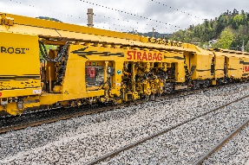 | Unimat 09-32/4S Dynamic.jpg | The Unimat 09-32/4S Dynamic with its refurbished tamping unit
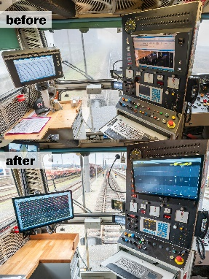 | Frontkabine before & after.jpg | The front cab before and after modification: replacement of DRP, SmartALC, and rear-view cameras with monitors

Plasser & Theurer in brief
- Founded in 1953
- Around 2,200 staff members in Austria
- Around 6,000 staff members at 22 partner companies throughout the world and in Austria
- Range of products: machines and systems for laying and installing, renewing, and maintaining tracks and overhead contact lines
- More than 17,700 heavy-duty machines supplied to 110 countries
- Export rate of 93%
- Main factory in Linz, head office in Vienna
- Service, repair, and spare parts depots all over the world
- Largest sales markets overall: Germany, USA, UK, India, Japan, France, Austria, Brazil, Spain, Australia
- Customers: railway operators, construction companies, urban transport authorities, industrial and mine railways
- More than 2,500 active patents
- 14 international certificates/qualifications (such as ISO 9001:2015, ISO 14001:2015, ISO 37001:2016, ISO 37301:2021, ISO 45001:2018, ISO 50001:2018)

Contact:
Plasser & Theurer, Export von Bahnbaumaschinen Gesellschaft m. b. H.
1010 Vienna, Johannesgasse 3
Tel.: +43 1 51572-0
Fax: +43 1 5131801
Email: presse@plassertheurer.com
https://www.plassertheurer.com/en/company/press
“Plasser & Theurer” and “Plasser” are internationally registered trademarks.

