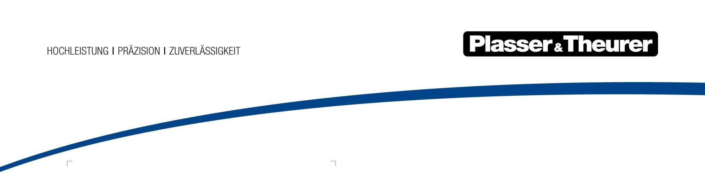

July 2024

Added value in the long term for the world’s railways
The 14th edition of InnoTrans, the world’s leading trade fair for transport technology, will take place in Berlin from 24 to 27 September 2024. Plasser & Theurer will once again be among the exhibitors in the railway infrastructure sector. In line with the slogan “future track technology – NOW”, the company will present innovations that offer added value in the long term for the world’s railways.
How can we react to the challenges posed by climate change as quickly as possible and in a sustainable way? How can the cost-effectiveness of track construction and maintenance continue to increase? And how can the shortage of skilled staff be addressed? These are three key questions of railways. As a technology leader in track construction, Plasser & Theurer feels obligated to answer these questions for the railway sector. There are solutions which mean long-term added value for both railways and railway construction companies.
Plasser & Theurer believes in the railway and sees itself as part of this system. There is no other transport system which is safer, more sustainable, and more economical. Only the railway is able to harmonize increasing mobility needs with the challenges of climate change. This is why the Austrian family-owned company is driven to create added value which continues to enhance the performance of this system.
Yellow machines GO GREEN
The first E³ machines, put into service in 2015, are emblematic of the paradigm shift in the track maintenance industry. These hybrid machines made emission-reduced travel and work possible for the first time. The remaining amount of hydraulic oil required went down drastically. It is only needed now for a few work sequences with high power requirements, such as lifting and lining the track. Furthermore, hybrid drive systems also have an impact on operating costs. When compared to diesel-hydraulic machines, hybrid machines save 40% of operating costs over a period of 20 years of operation.
The experience gained in the past years allows Plasser & Theurer to offer E³ tamping machines as well as E³ machines for overhead contact line installation as a permanent part of its product range. The fact that E³ machines already account for approximately 20% of the current contract volume shows how much the company is catering to the market.
Better availability of permanent way thanks to new offers for infrastructure
In March 2023, a single track inspection vehicle by Plasser & Theurer was able to measure 61 turnouts in St. Pölten, Austria in one night. It only took four minutes per turnout. This demonstrates the amount of expertise the company has acquired after building over 200 track inspection vehicles. Furthermore, it also shows the potential which arises from the digitalization of track maintenance processes.
Another example is the Plasser TampingAssistant, which automatically positions, configures, and controls tamping units with the help of AI. Operators only need to confirm the system suggestions and monitor the process. The system allows even inexperienced operators to deliver high-quality tamping results. In addition, Plasser TampingControl provides data on the quality of the superstructure and tamping process in real time. It optimizes the filling and compaction process in a groundbreaking way. Finally, the Plasser TampingReport provides digital documentation of the entire process, i.e. transparent proof of the work result.
Sustainable strategies for a lack of skilled staff
The lack of skilled staff poses a major challenge to railways. Plasser & Theurer offers several solutions. One of them is to create even more attractive workspaces on the machines. The best example of that is the E³ machines, with their comfortably furnished crew areas and cabs featuring digital controls which make work simpler and more comfortable. Another approach is to automate processes, making it easier to complete tasks with less staff in the first place. The Plasser TampingAssistant shows how this can be achieved on tamping machines. In addition, Plasser & Theurer offers simulators which allow new operators and career changers to practise operating the machines in a secure environment with supervision from experienced instructors. Doing so reduces training time and allows staff to begin working quicker. The simulators available range from tamping-machine simulators to those for ballast distributing and profiling machines and ballast cleaning machines. The company offers track inspection vehicles, such as the EM100VT or the EM120VT, as a third option: nowadays they make it possible to complete measuring tasks for infrastructure much faster and with less staff.
Focus on global needs
As a company with global reach, it is Plasser & Theurer’s goal to supply the right track maintenance machine for all of the world’s regions. Although the underlying working principles are similar, specific requirements often differ significantly from country to country. To be able to meet these requirements, the company’s Compact portfolio offers compact machines in the Plasser & Theurer quality standard. It covers the entire spectrum of track maintenance, from tamping and stabilization to profile finishing. Thanks to network configurations for everything from narrow to broad track gauge or for tight vehicle gauges and low axle loads, these vehicles can be used in practically any region around the world. Special designs are also available, for example, for local public transport. These machines are high in demand. It was only in 2023 that the track maintenance machine manufacturer was awarded the contract to supply 41 machines for renewing the fleet of the Taiwan Railways Corporation.
A partner you can count on over the entire life cycle of the machines
Around half of all 17,800 machines built are still in operation. This highlights the quality of manufacturing and is also a quality indicator for Plasser & Theurer’s global services. The Customer Services division is in charge of these services, which have been winning over customers over the entire life cycle of the machines. Maintenance services for individual machines and entire fleets are highly sought out, as are retrofits: major refurbishments are used to perform technical upgrades at the same time. The latest service is for used machines which includes purchasing used machines and making them fit for new applications before reselling them. This option is ideal for companies that are new to the track maintenance business, allowing them to benefit from time-tested quality.
With innovative ideas such as these services and, of course, with a complete selection of new, future-oriented technologies, Plasser & Theurer is contributing to tackling the challenges of our time. And it helps to make the world’s railways even safer, more sustainable, and more cost-effective.

Take time for your visit to InnoTrans and meet us in Hall 26 (Stand 270) and on the outdoor display south (T2/50 + 55, T3/50).

Image | File name | Caption
 | Unimat 09-8x4/4S BR Dynamic E³.jpg | 10 years of track maintenance machines with alternative drives by Plasser & Theurer – ecologically future-proof, powerful, and economically feasible.
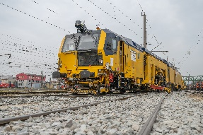 | Unimat 09-4x4/4S E³.jpg | Safety thanks to the on-board AI pro: the Plasser TampingAssistant uses artificial intelligence to assist with operating modern universal tamping machines.
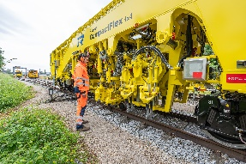 | Plasser CompactFlex 4x4.jpg | Versatile solutions for global track maintenance: Plasser & Theurer’s Compact series covers the entire spectrum of track maintenance, from tamping and stabilization to profile finishing.
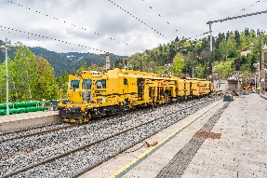 | Unimat 09-32/4S Dynamic.jpg | Retrofit for STRABAG AG’s Unimat 09-32/4S Dynamic: after four short months, the universal tamping machine is already back in operation at Semmering.

Plasser & Theurer in brief
- Founded in 1953
- Around 2,200 staff members in Austria
- Around 6,000 staff members at 22 partner companies throughout the world and in Austria
- Range of products: machines and systems for laying and installing, renewing, and maintaining tracks and overhead contact lines
- More than 17,800 heavy-duty machines supplied to 110 countries
- Export rate of 93%
- Main factory in Linz, head office in Vienna
- Service, repair, and spare parts depots all over the world
- Largest sales markets overall: Germany, USA, UK, India, Japan, France, Austria, Brazil, Spain, Australia
- Customers: railway operators, construction companies, urban transport authorities, industrial and mine railways
- More than 2,500 active patents
- 14 international certificates/qualifications (such as ISO 9001:2015, ISO 14001:2015, ISO 37001:2016, ISO 37301:2021, ISO 45001:2018, ISO 50001:2018)

Contact:
Plasser & Theurer, Export von Bahnbaumaschinen Gesellschaft m. b. H.
1010 Vienna, Johannesgasse 3
Tel.: +43 1 51572-0
Fax: +43 1 5131801
Email: presse@plassertheurer.com
https://www.plassertheurer.com/en/company/press
“Plasser & Theurer” and “Plasser” are internationally registered trademarks.

